Question 1: (Conversion Epsilon NFA to DFA)
Construct the DFA from the Epsilon NFA given in figure.
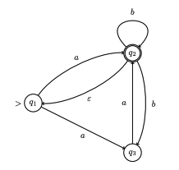

Question 2: (Conversion epsilon-NFA to DFA)
Construct the DFA from the Epsilon NFA given in figure 1.
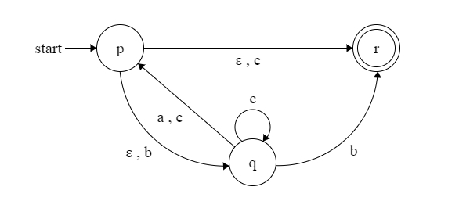

Figure 1
Note: Show steps of your method properly to get full credit.

Question 3: (Conversion NFA to DFA)
Construct the DFA from the NFA given in figure.

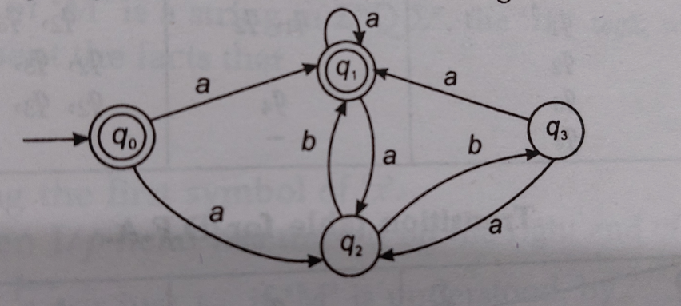

Question 4:
1. Find the Concatenation of FA1 and FA2 given in Figure 1 and Figure 2.
2. Find the Union of FA1 and FA2 given in Figure 1 and Figure 2.
3. Find the Intersection of FA1 and FA2 given in Figure 1 and Figure 2.
4. Find the Closure of FA1 given in Figure 1.

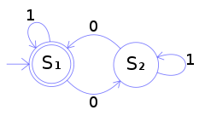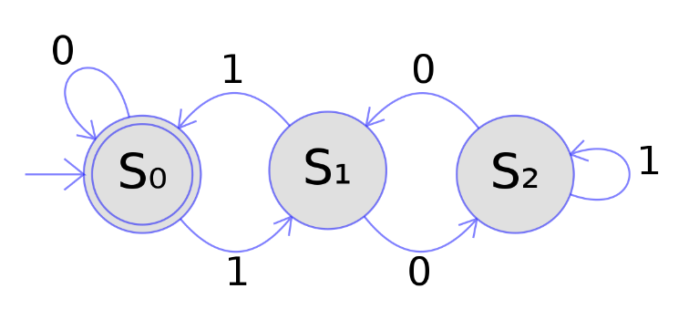
Figure 1 Figure 2
Note: Show steps of your method properly to get full credit.

